**Crop Monitoring System**

A major project report submitted in partial fulfillment of the requirement for the award of degree of

**Bachelor of Technology**

in

**Computer Science & Engineering / Information Technology**

*Submitted by*

**Anmol Bhopal ( 201191 )**

**Anmol Sharma ( 201199 )**

*Under the guidance & supervision of*

**Professor Dr. Pradeep Kumar Gupta**



**Department of Computer Science & Engineering and**

**Information Technology**

**Jaypee University of Information Technology, Waknaghat, Solan - 173234 (India)**

**CERTIFICATE**

**DECLARATION**

I hereby declare that the work presented in this report entitled **‘Crop Monitoring System’** in partial fulfillment of the requirements for the award of the degree of **Bachelor of Technology** in **Computer Science & Engineering / Information Technology** submitted in the Department of Computer Science & Engineering and Information Technology**,** Jaypee University of Information Technology, Waknaghat is an authentic record of my own work carried out over a period from August 2023 to December 2023 under the supervision of **Professor Dr. Pradeep Kumar Gupta** (Associate Dean , Department of Computer Science & Engineering and Information Technology).

The matter embodied in the report has not been submitted for the award of any other degree or diploma.

(Student Signature with Date)

Anmol Bhopal

(201191)

Anmol Sharma

(201199)

This is to certify that the above statements made by the candidates are true to the best of our knowledge.

(Supervisor Signature with Date)

Prof. Dr. Pradeep Gupta

Associate Dean

Computer Science & Engineering and Information Technology

**ACKNOWLEDGEMENT**

Firstly, we express our heartiest thanks and gratefulness to almighty God for His divine blessing makes it possible for us to complete the project work successfully.

We are really grateful and wish our profound indebtedness to **Supervisor Professor Dr. Pradeep Kumar Gupta**, Department of CSE, **Jaypee University of Information Technology, Wakhnaghat**. Deep Knowledge & keen interest of our supervisor in the field of “Remote sensing and IOT” to carry out this project. Her endless patience, scholarly guidance, continual encouragement, constant and energetic supervision, constructive criticism, valuable advice, reading many inferior drafts and correcting them at all stages have made it possible to complete this project.

We would like to express our heartiest gratitude to Professor Dr. Pradeep Kumar Gupta, Department of CSE, for their kind help to finish my project.

We would also generously welcome each one of those individuals who have helped us straightforwardly or in a roundabout way in making this project a win. In this unique situation, We might want to thank the various staff individuals, both educating and non-instructing, which have developed their convenient help and facilitated our undertaking.

Finally, We must acknowledge with due respect the constant support and patience of our parents.

Anmol Bhopal (201191)

Anmol Sharma (201199)

# TABLE OF CONTENTS

| **S. No.** | **Title** | **Page No.** |
| --- | --- | --- |
| 1. | Certificate | II |
| 2. | Declaration | III |
| 3. | Acknowledgement | IV |
| 4. | Abstract | VIII - IX |
| 5. | CHAPTER 1: INTRODUCTION | 01 - 09 |
| 6. | CHAPTER 02: LITERATURE SURVEY | 10 - 13 |
| 7. | CHAPTER 03: SYSTEM DEVELOPMENT | 14 - 36 |
| 8. | CHAPTER 04: Testing | 37 - 41 |
| 9. | CHAPTER 05: Results and Evaluation | 42 - 46 |
| 10. | CHAPTER 06: Conclusion and Future scope | 47`- 49 |
| 11. | References | 50 - 53 |

**List of Abbreviations**

| **Abbreviation** | **Names** |
| --- | --- |
| IoT | Internet Of Things |
| pV | Photovoltaic Effect |
| FCC | Federal Communications |
| CDP | Connected Device Platform |
| IDE | Integrated Development Environment |
| ICP | IoT Creators Protocol |
| GPS | Global Positioning System |
| LCD | Liquid Crystal Display |
| VCC | Voltage Common Collector |
| SFLR | Short For Long Range |
| AND | Analog Navigator Digitance |

# 

# List of Tables

| **S. No.** | **Figure** | **Page No.** |
| --- | --- | --- |
| Table 2.1 | Tabular Summary of Literature Survey page | 13 |

# 

# List of Figures

| **Fig. No.** | **Figure** | **Page No.** |
| --- | --- | --- |
| 1 | Table 2.1 | 13 |
| 2 | IoT Based Agriculture Monitoring | 16 |
| 3 | IoT Based Agriculture Monitoring And Control System | 22 |
| 4 | Arduino Uno Atmega 328P | 23 |
| 5 | LCD ( Liquid Crystal Display) | 28 |
| 6 | Adafruit Software ( ThingSpeak Cloud Server ) | 32 |
| 7 | Block Diagram Of Methodology | 39 |

**ABSTRACT**

Over 60% of the population in India depends on agriculture for their livelihood, and it generates a sizable portion of the country's GDP. However, the nation's progress is hampered by a number of issues. It is imperative to adopt modern agricultural practises in order to overcome these challenges. The potential for transforming agriculture into a smart and efficient industry exists in the integration of IoT and other contemporary technologies.

Using digital technology in crops, including drip irrigation, reduces water losses in agriculture while improving the use of fertilizers. An Arduino-powered agriculture monitoring system utilizes wirelessSensor Networks for collecting information from different nodes which is then sent out wirelessly. The system comprises of temperature, moisture, water level sensors, a motor DC and a GPRS Module.

The system based on IoT monitors parameters such as the water level, humidity, and moisture continuously. It sends out SMS notifications in real time for users to be alerted and activates devices like a water pump where liquid levels reduce or activates fans where temperatures rise beyond set levels. These values are captured on an LCD and an IoT platform with a minute-by-minute update for the measures on humidity, moisture, and water levels. It features a stopping button for the water pump in the IoT interface and has an adaptive setting, considering what crops it is cultivated for.

This project is characterized by the measurement of important agricultural parameters, the integration of GPS for location data, the sending of data to the cloud for additional analysis, and the development of an Android app for convenient farmer access. To maximize water use, it also introduces a smart irrigation system. Over the ages, agriculture has changed and is still an essential part of human civilization. Modernizing agriculture becomes imperative as technology progresses, and IoT emerges as a key instrument. IoT sensors enable automation and efficiency in agriculture by offering critical insights. The suggested Internet of Things (IoT)-based smart agriculture system makes use of Arduino technology and wireless sensor networks to keep an eye on vital variables like water, moisture, and temperature.

Based on parameters it has detected, this monitoring system initiates actions, sending SMS alerts and turning on fans and water pumps as needed. Accurate agricultural data with timestamps is presented in real-time on LCD modules and IoT platforms. Furthermore, it enables temperature adjustments based on the crops being grown and offers controls for water flow management via the Internet of Things interface.

In order to improve productivity and change farming practises, modern agriculture needs efficient crop monitoring systems. This abstract examines the layout, capabilities, and uses of an all-inclusive crop monitoring system to provide farmers with precise and timely information.

By integrating advanced technologies like remote sensing, IoT devices, data analytics, and user-friendly interfaces, the proposed system facilitates comprehensive data collection, analysis, and interpretation. Its functionalities include early detection of pest infestations, diseases, and nutrient deficiencies through data-driven analytics. Farmers are able to make educated decisions about crop management practises, fertilisation, pest control, and irrigation schedules by using predictive modelling in conjunction with real-time crop monitoring

# CHAPTER 1: INTRODUCTION

## 1.1 INTRODUCTION

The Internet of Things (IoT) represents the interconnected network of physical devices, including computing devices, digital and mechanical machines, along with people or animals, enabling these objects to sense, collect, and transmit data over the web without requiring human involvement. Each item within this network possesses a unique identifier. IoT involves advanced examination and automated frameworks that utilize detection, organization, vast data, and artificial intelligence technologies to create a comprehensive administrative framework. Essentially, IoT expands the capabilities of the internet beyond smartphones and computers.

IoT has significantly impacted our world today. Everything around us, from smart cities to smart cars and smart homes, can be transformed into intelligent devices with the assistance of IoT. Its applications extend to various sectors such as agriculture, business, healthcare, transportation, and logistics.

The three primary components of IoT are:

**1. Low-power embedded systems:** These systems are designed considering high performance and minimal battery consumption, which are critical factors in electronic system design.

**2. Cloud computing:** Data gathered from devices is securely stored on reliable storage servers, utilizing cloud computing infrastructure.

**3. Network connection:** Internet connectivity is essential for communication, with each physical object assigned its unique IP address.

Utilizing IoT technology for monitoring agricultural parameters can significantly enhance plant performance, monitoring capabilities, and maintenance processes. The decreasing global cost of renewable energy equipment due to technological advancements encourages the implementation of large-scale agriculture.

##### IoT in Agriculture:

The Internet of Things (IoT) holds the potential to significantly enhance global living standards. With the world's population expected to surpass 3 billion in the coming years, the agricultural industry must adopt IoT to meet the food demands of such a vast populace. Addressing the challenges posed by extreme climate conditions, weather fluctuations, and environmental impacts resulting from farming practices is crucial. According to the United Nations' Food and Agriculture Organization, worldwide food production needs to increase by 70% by 2050 to accommodate the growing population.

Agriculture serves as the foundation for humanity, being the primary source of sustenance, and significantly contributes to a country's economic growth. It also offers substantial employment opportunities. However, reliance on traditional agricultural methods often leads to low crop yields. Implementing automatic machinery can improve crop productivity.

Integrating modern science and technology into agriculture is essential for boosting yields. IoT implementation can lead to increased production at a lower cost by monitoring soil efficiency, temperature, humidity, rainfall, fertilizer effectiveness, water tank storage capacity, and detecting theft in agricultural areas. The future of Indian agriculture hinges on adopting advanced technologies that can enhance production and attract farmers to the industry. Smart farming techniques can help reduce wastage and improve productivity. It's a technologically advanced and capital-intensive system aimed at sustainable mass crop production.

This technology allows farmers to remotely monitor field conditions using sensors and automate irrigation systems. It involves the application of Information and Communication Technology in agriculture. The project focuses on implementing a cost-effective IoT-based methodology to remotely evaluate plant performance. The data obtained from this project can be utilized globally for the advancement of agriculture.

The sensor layer encounters a challenge in converting real-time agricultural data into digital information suitable for processing in the virtual world. This layer collects various data types, including sensor information like humidity, temperature, gas concentrations, pressure, product details such as name, model, price, and features, operational parameters of equipment, and location information. Techniques like RFID tags, cameras, two-dimensional code labels, and sensor networks constitute this layer. The Information layer faces the challenge of categorizing and acquiring diverse data types from the real world through sensing techniques, transforming them into digital information for processing. Strategies used in this layer involve marking and gathering information using sensors and then processing them into digital data.

1) The Transport layer is responsible for gathering and summarizing agricultural data collected from the previous layers for further processing. It serves as the core of IoT, incorporating telecommunication management centers, internet networks, information centers, and smart processing hubs.

2) The Application layer analyzes and processes collected information to develop digital insights into the real-world cultivation. This layer represents the convergence of IoT and agricultural market intelligence.

**Benefits of IoT in Agriculture:** The Internet of Things makes it simple to gather and handle enormous volumes of sensor data. Information is easily accessible from any location by integrating distributed evaluation services like cloud storage and agricultural field maps. According to experts, precise sensor usage and smart devices can help farmers increase output by up to 72% by 2050, which is why IoT is essential to smart farming.- Implementing IoT innovations can significantly reduce expenses, leading to increased productivity and sustainability. By putting IoT innovations into practise, costs can be drastically cut, which boosts sustainability and productivity.

## 1.2 PROBLEM STATEMENT

A crop monitoring system offers thorough oversight and analysis of crop health, growth, and environmental conditions, making it a vital tool for modern agriculture. This system gathers, processes, and interprets data that is essential for efficient farm management by integrating a number of technologies, including data analytics, remote sensing, and the Internet of Things.

Basically, the system uses remote sensing methods to gather precise data regarding crop health, moisture content, and overall growth. These methods include satellite imagery and drones fitted with multispectral cameras. Farmers are able to identify possible problems such as disease outbreaks, pest infestations, or nutrient deficiencies early on thanks to the processing of these images by specialised software that looks for patterns and anomalies.

The system also includes on-field sensors that track temperature, moisture content of the soil, and other pertinent variables continuously Together with historical data and predictive models, this real-time data assists farmers in making well-informed decisions about fertilisation schedules, irrigation schedules, and pest management tactics.

This monitoring system usually produces comprehensive reports, maps, and useful insights that are accessed via intuitive user interfaces. These insights enable farmers to promote sustainable agricultural practises while optimising resource allocation, minimising crop losses, and improving overall yield.Together with historical data and predictive models, this real-time data assists farmers in making well-informed decisions about fertilisation schedules, irrigation schedules, and pest management techniques.

In the end, a crop monitoring system is a proactive tool that helps farmers make informed decisions based on data, reduce risks, and increase yield—all of which add to sustainability and efficiency.

**1.3 OBJECTIVE**

A crop monitoring system plays a crucial role in modern agriculture, aiming to transform farming practices by leveraging technology to improve productivity, sustainability, and efficiency. The primary objective of this system is to furnish farmers with comprehensive, real-time insights into crop health, environmental conditions, and potential challenges. This empowerment enables informed decision-making for optimized agricultural outcomes.

1. To acquaint farmers with new technology and eliminate manual labor.

2. To minimize water wastage and enhance crop productivity by providing ideal conditions.

3. To address challenges like severe weather conditions, advancing climate change, and environmental impact resulting from intensive farming practices.

4. To design a model integrated with an android app and cloud server.

Leveraging the Internet of Things (IoT) technology for monitoring agriculture parameters can significantly enhance plant performance, monitoring, and maintenance. As technology advances, the cost of renewable energy equipment is decreasing globally, encouraging large-scale agriculture. This project involves implementing a new cost-effective methodology based on IoT for remotely monitoring plant performance evaluation. Additionally, the project aims to gather data usable worldwide for the improvement of agriculture.

Considering that there will be 9.6 billion people on the planet by 2050, the agriculture industry must use IoT to meet the rising demand for food. Problems like intensifying climate change, erratic weather patterns, and the environmental effects of intensive farming practises exacerbate this demand. Agri-Tech greenhouse companies use Internet of Things (IoT) technologies to offer services, building modern, affordable greenhouses with solar-powered IoT sensors. These sensors provide an online portal for monitoring, send SMS alerts to farmers, and actively monitor greenhouse conditions and water usage..

**1.4 Motivation of the project work**

The project stems from a recognition of various issues faced by farmers, driving us to propose a system that addresses these challenges. Indian agriculture encounters obstacles due to limited knowledge of advanced agricultural practices, heavy reliance on conventional methods resulting in lower crop productivity, and the burden of substantial loans farmers incur to sustain their livelihoods and achieve better yields.

Furthermore, resource scarcity exacerbates these challenges, hindering or preventing farmers from cultivating their lands. This has a significant impact on the Indian economy as productive lands vital to the nation's GDP are being adversely affected.

Hence, our framework aims to introduce automated and systematic farming strategies that enable farmers to cultivate in a more productive manner with limited resources, ensuring higher yields and efficiency. The motivation behind initiating a crop monitoring project encompasses several factors and seeks to address critical challenges in agriculture while leveraging technological advancements.

**Motivations driving such projects include:**

**1. Enhancing Agricultural Productivity:** Improving crop yields and overall agricultural output is a primary goal. Crop monitoring systems aim to optimize farming practices to increase productivity and profitability for farmers.

**2. Sustainable Agriculture:** Encouraging sustainable farming practices is crucial. Monitoring systems aid in minimizing resource wastage, reducing environmental impact, and promoting responsible use of water, fertilizers, and pesticides.

**3. Risk Mitigation:** Agriculture faces various risks such as pests, diseases, adverse weather, and market fluctuations. Crop monitoring systems aim to mitigate these risks by providing early warnings, enabling proactive measures to minimize losses.

**4. Resource Optimization:** Efficient utilization of resources like water, fertilizers, and energy is essential. Monitoring systems assist farmers in optimizing resource allocation based on real-time data, reducing input costs, and minimizing environmental impact.

**5. Precision Agriculture:** Leveraging technology for precision farming is a key driver. Crop monitoring systems enable precise and targeted interventions, allowing farmers to tailor actions specific to each crop's needs, thereby enhancing efficiency.

**Proposed Approach**

The proposed crop monitoring system offers a comprehensive and adaptable solution intended to empower farmers with essential tools and information, enhancing crop yields, optimizing resource utilization, and fostering sustainable agricultural practices. The purpose of a crop monitoring system is to furnish farmers and stakeholders with precise, real-time information to improve agricultural productivity, sustainability, and decision-making. Here's an approach outlining the purpose and methodology of such a system:

**Data Acquisition:**

- Multi-source Data Collection: Gather data from diverse sources such as satellites, drones, on-field sensors, weather stations, and historical records.

- Remote Sensing Technologies: Employ satellite imagery and sensor-equipped drones for comprehensive field monitoring

**Data Integration and Processing:**

- Integration of Diverse Data: Aggregate and process data from various sources to create a comprehensive view of crop health, soil conditions, weather patterns, etc.

- Real-time Data Processing: Implement algorithms and analytics for swift processing of incoming data, enabling immediate insights.

**Analytics and Insight Generation:**

- Advanced Algorithms: Develop robust algorithms for anomaly detection, predictive analysis, and trend identification.

- Actionable Insights: Generate actionable insights and recommendations for farmers, focusing on irrigation scheduling, pest management, and resource optimization.

**User-friendly Interfaces and Accessibility:**

- Intuitive Dashboards: Design user-friendly interfaces and mobile applications for easy access to insights and recommendations.

- Accessibility and Training: Ensure usability for farmers of varying technical expertise through training and accessible interfaces.

**Real-time Monitoring and Alerts:**

- Alert Systems: Establish alert mechanisms for early detection of anomalies, pest outbreaks, or adverse weather conditions.

- Timely Notifications: Deliver timely notifications to farmers via SMS, email, or app notifications.

**Scalability and Adaptability:**

- Scalable Architecture: Design the system for seamless scalability to cover larger agricultural areas and accommodate increasing data volumes.

- Adaptation to Different Crops: Ensure adaptability across various crops and farming practices.

**Validation and Iteration:**

- Field Validation: Conduct field trials to validate the system's accuracy and effectiveness in real agricultural settings.

- Continuous Improvement: Gather user and stakeholder feedback to iteratively refine algorithms, interfaces, and functionalities.

The integration of IoT in crop monitoring comes with challenges such as availability issues in remote regions, concerns regarding data security, and high initial setup costs. Moreover, handling extensive datasets may overwhelm farmers lacking the necessary skills for data analysis. Addressing these challenges will be crucial in ensuring widespread adoption and maximizing the potential of IoT in agriculture. Developing a crop monitoring system involves a systematic approach combining diverse technologies and methodologies to ensure effective crop monitoring and management.

**Needs Assessment and Requirement Gathering**

Understanding the specific needs and challenges of farmers and agricultural stakeholders is essential. Gathering requirements through consultations, surveys, and field visits to tailor the system to meet the diverse needs of users.

Technology Selection and Integration: Identifying and selecting appropriate technologies, including remote sensing (satellite imagery, drones), IoT sensors, and data analytics platforms. Integrating selected technologies into a cohesive system for data collection, processing, and analysis.

Data Collection and Acquisition: Implementing methods to collect diverse data, including soil moisture, temperature, crop health indicators, and weather forecasts.Utilizing remote sensing technologies for high-quality images and multispectral data for comprehensive field monitoring.

Data Processing and Analysis: Developing algorithms and analytics to process collected data for accuracy and reliability. Analyzing data to derive meaningful insights into crop health, growth stages, environmental conditions, and potential risks.

User Interface and Accessibility: Designing user-friendly interfaces, dashboards, or mobile applications to present actionable insights in an understandable format. Ensuring accessibility and usability for farmers with varying technical expertise. Real-time Monitoring and Alerts: Implementing systems for real-time monitoring of data streams, generating alerts for anomalies, pest outbreaks, or adverse weather conditions. Enabling timely notifications to farmers through SMS, email, or app notifications.

**CHAPTER 02: LITERATURE SURVEY**

**2.1 Overview**

The Internet of Effects (IoT) constitutes a connected network of objects or entities that interact through the internet. IoT plays a importnt role in the agricultural industry, aiming to support the projected 9.6 billion population by 2050. Smart Agriculture contributes to minimizing destruction, optimizing toxin operation, and increasing crop yield. This project involves developing a system to cover crop-fields using detectors (soil, humidity, temperature, moisture, light).

[1] In a paper by S. Sivacharan, K. Balkrishnan, and K. Navin, an embedded soilanalyzer measures the soil's pH value and provides data on soil nutrients, aiding in soil fertility prediction. It aims to automate soil testing to replace conventional methods.

Another paper introduces an IoT-based smart stick for live monitoring of agricultural parameters. This stick provides real-time report on temperature and soil humidity, enabling immediate monitoring by farmers through smart devices like tablets and phones.

[2] Anand Nayyar and Er. Vikram Puri proposes a model monitoring water inflow and direction with DHTT11 and soil humidity detectors. This model allows remote control of field operations through mobile devices.

IoT and smart agriculture using automation focus on monitoring environmental factors crucial for improving crop yields. CC3200 single-chip technology is used for temperature and moisture monitoring in agricultural fields. Additionally, a camera connected to CC3200 captures and transmits field images to a grower's mobile via Wi-Fi.

[3] Apurva C. Pusatkar and VijayS. Gulhane concentrate on Wireless Sensor Network (WSN) for real-time monitoring of agricultural fields. This paper expands parameters to include water position, flood tide, wind direction, wind speed, and rainfall.

The paper addresses the challenge of low productivity in India and aims to achieve an 'evergreen revolution' in agriculture. It emphasizes automating data collection and focuses on enhancing crop yield through various technologies, presenting a cost-effective WSN for moisture, soil humidity, and temperature detection.

[4] Dr. N. Suma, S.R. Samson, and S. Saranya propose a GSM-based model and PIR detector for real-time monitoring and decision support in agriculture. This model integrates multiple detectors and technologies, transmitting measured values over the air.

The paper describes an IoT-based monitoring system utilizing a microcontroller, GSM module, Bluetooth module, SD card module, and detectors to gather and transmit field data to a server via GSM network.

Lastly,

[5] An IoT-grounded husbandry parameter monitoring system measures temperature, moisture, humidity, and pH using separate detectors. The data is uploaded to thethinger.io IoT platform for remote access. This system aims to provide growers with soil and environmental data through an IoT platform, generating alerts based on predefined thresholds.

This system can significantly aid growers in monitoring soil and environmental parameters through the IoT platform. By setting predefined thresholds for moisture, temperature, humidity, and pH, alerts can be triggered for anomaly detection. Additionally, traditional classification methods form the backdrop of this system. Four distinctive techniques—KNN, Naive Bayes, SVM, and ANN—are examined across various color spaces. The intricate combination of colors, including RGB, HSV, and YCbCr, poses a challenge in distinguishing between pixels. Declining crop yield is attributed to unpredictable monsoon rainfalls, water scarcity, and improper water usage.

In essence, the methodology of a crop monitoring system revolves around systematically collecting, analyzing, and utilizing data. This empowers farmers with timely, accurate, and actionable information for efficient crop management and decision-making.

**2.2Key Gaps in Literature**

The agricultural industry stands as a crucial foundation for sustaining humanity. Managing food supply globally becomes increasingly critical. Many farmers traditionally employ conventional techniques to cultivate their crops. Previously, physically visiting the farm was the primary means of monitoring crops. Leveraging technology can significantly simplify and expedite this task. The "Internet of Things" (IoT) technology enables the transmission and reception of various data types over the Internet to a server. This facilitates remote monitoring of crop conditions for farmers, even when they are not physically present. This paper proposes an IoT-based system for monitoring farming fields, allowing different devices and sensors to function in tandem .

A prevalent challenge in numerous agricultural regions revolves around the lack of mechanization in farming activities. In India, agricultural work primarily relies on manual labor and traditional tools like plows and sickles. Our Smart Farming System aims to reduce manual labor and automate agricultural activities .

The amalgamation of traditional farming practices with modern technologies such as the Internet of Things (IoT) and Wireless Sensor Networks holds the potential for agricultural modernization. Wireless Sensor Networks facilitate data collection from various sensors, transmitting it to the main server using wireless protocols. Several factors greatly influence productivity, including pest attacks that can be managed through proper pesticide spraying. Additionally, challenges arise from wild animal attacks as the crop matures. Crop yields are diminishing due to erratic monsoon rains, water scarcity, and inefficientwater usage. In essence, a crop monitoring system's methodology revolves around systematically collecting, analyzing, and leveraging data to empower farmers with timely, accurate, and actionable insights for effective crop management and decision-making.

Field testing remains essential to confirm the system's accuracy and functionality under real operating conditions. Iterative improvements will involve gathering user input and making system enhancements based on real-world experiences and observations.

|  |  |  |  |  |
| --- | --- | --- | --- | --- |
| **S. No.** | **Research Paper Title** | **Author(s)** | **Publication Year** | **Key Findings** |
| 1. | RealNTime Embedded BasedJSoil Analyser | Sivachandran, K.Balakrishnan, K.Navin (IRJET). Volume: 3 Issue 3 | 2014 | provides prompt and effective soil analysis for applications in precision agriculture. |
| 2. | IoT BasedHSmart Sensors AgricultureBStick for Live  TemperatureKand Moisture Monitoring | Anand Nayyar, Er. Vikram Puri. | 2015 | Monitoring temperature and moisture in real time for improved agricultural management |
| 3. | A Low Cost SmartIrrigation Control System | Chandan Kumar Sahu, Pramitee Behera IEEE ,(ICECS2015) | 2015 | shows promise for streamlining irrigation systems to conserve resources. |
| 4. | IOT Based Crop-FieldgMonitoring And  Irrigation Automation | Mrs.S.Devi Mahalakshmi, Rajalakshmi.P, (ISCO) IEEE Xplore | 2016 | improve resource optimisation, water management, and agricultural efficiency |
| 5. | Detection.and ControlKfor Agriculture Applications | Laxmi C. Gavade, A.D Bhoi, (IRJET).  Volume: 6 Issue: 4 | | 2017 | PIC Controller to enhance crop management in precision agriculture applications. |

**Figure-1**

**CHAPTER 03: SYSTEM DEVELOPMENT**

# 3.1 Requirement and Analysis

A number of sensors, including temperature, moisture, light, and DHT 11 sensors, are placed in the field section. Through the ESP8266, the Arduino is connected to the data gathered from these sensors.

The received data is checked against the threshold values in the control section. The buzzer turns on and the LED begins to flicker if the data exceeds the threshold value.The farmer receives a notification from this alert, and upon sensing, the power is automatically turned off. The farmer receives a comprehensive description of the values once they are generated on the webpage.

A moisture sensor will detect the presence of water in the soil.

A sunlight sensor will detect the sun's intensity and record it.

**Analysis of Crop monitoring system**

The incorporation of IoT into crop monitoring systems has significantly transformed horticulture. These systems leverage diverse sensors, robots, and data analysis, providing farmers with real-time data on soil moisture, temperature, humidity, and crop growth, offering a holistic view of their fields' conditions.

One key advantage is precision agriculture. Through IoT, farmers can precisely determine when and where to irrigate, fertilize, or apply pesticides, reducing resource wastage and maximizing yield. Monitoring systems also aid in early pest detection, enabling timely interventions to prevent widespread crop damage.

Moreover, the accessibility of data through mobile applications or web platforms allows farmers to make informed decisions remotely. Historical data analysis further assists in identifying patterns, optimizing planting plans, and enhancing overall farm management techniques.

However, the integration of IoT in crop monitoring faces challenges such as connectivity issues in remote areas, data security concerns, and high initial setup costs. Additionally, interpreting vast datasets can overwhelm farmers who lack the necessary skills to analyze the information.

Nevertheless, the potential benefits of IoT in crop monitoring are immense, fostering sustainable agricultural practices, reducing environmental impact, and improving efficiency. Addressing these challenges will be crucial to ensure widespread adoption and maximize IoT's potential in agriculture.

Crop monitoring systems using IoT technology have become integral in modern agriculture, fundamentally changing traditional farming practices. These systems comprise an array of sensors, robots, and data analysis that collectively provide a comprehensive and real-time view of various crop parameters, streamlining decision-making processes for farmers.

One of the primary benefits lies in precision farming. IoT-based sensors monitor crucial elements like soil moisture, temperature, and nutrient levels, enabling farmers to customize their irrigation, fertilization, and pest control procedures precisely. This targeted approach minimizes resource wastage, reduces operational costs, and ultimately enhances crop yields. The integration of IoT devices in crop monitoring also facilitates early detection of potential issues. Continuous data collection enables prompt identification of anomalies in crop growth patterns, pest infestations, or diseases. Timely intervention, based on this data, enables farmers to mitigate risks effectively, preventing significant losses. Access to data is another key advantage. Farmers can access comprehensive insights and analysis through user-friendly interfaces on mobile applications or web platforms. This accessibility enables them to make informed decisions remotely, enabling better planning and management of their farms. However, despite the enormous potential, challenges hinder the extensive adoption of IoT in crop monitoring systems. Connectivity issues in remote agricultural areas limit the seamless transmission of data. Additionally, ensuring the security of collected data against cyber threats is crucial, especially considering the sensitive nature of agricultural data. Moreover, the initial setup cost for implementing IoT devices and the required infrastructure could be a barrier for smaller-scale farmers.

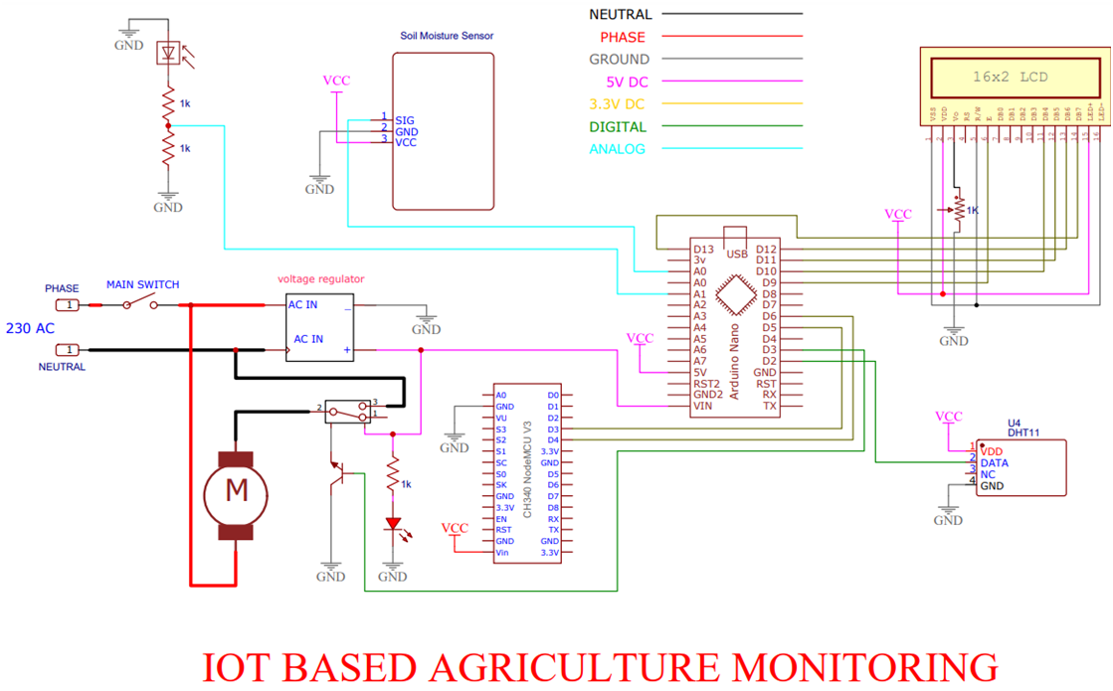In essence, the methodology of a crop monitoring system revolves around the systematic collection, analysis, and utilization of data to empower farmers with timely, accurate, and actionable information for efficient crop management and decision-making. The architecture of an IoT-based Agriculture Monitoring System comprises a hierarchical structure that seamlessly integrates sensors, IoT devices, connectivity mechanisms, cloud platforms, data analytics, user interfaces, and security measures. At its foundation lie sensors dispersed across agricultural fields, capturing real-time data on soil moisture, temperature, humidity, weather conditions, and crop health indicators. These sensors relay information to IoT gateways, acting as data aggregators and forwarders, leveraging diverse communication protocols for efficient transmission to the cloud platform. Within the cloud environment, data processing and analytics take center stage, employing algorithms and machine learning models to process incoming data streams, extract valuable insights, and predict patterns crucial for informed decision-making. The resultant insights, encompassing crop health assessments, irrigation recommendations, and pest risk alerts, are seamlessly conveyed to users through intuitive interfaces—be it web portals or mobile applications—enabling farmers to access actionable information in real-time. As a critical facet, robust security measures, including encryption protocols and access controls, safeguard the integrity and privacy of agricultural data throughout its transmission and storage within the system. This architecture fosters a scalable, adaptable, and user-centric ecosystem that empowers farmers with comprehensive, data-driven insights, revolutionizing agricultural practices and enhancing crop management strategies.

**Figure-2**

**3.2 Project Design and Architecture**

Developing an IoT crop monitoring system consists of various stages and techniques. This is a methodical strategy:

1. Defining the Objectives and Needs:

Identify the Needs Particular to a Crop: Identify what type of crop variety, growing conditions, or other factors that could aid in the growth and production stages of the plant.

Set Goals: Regardless of whether the system is for tracking soil moisture, temperature, humidity or for pest detection, it is important to identify the objectives of the system.

2. Sensor Positioning and Selection:

Choose the Sensors: Choose the right IoT sensors (including cameras for visual inspection, temperature and humidity sensors, and the ones for measuring soil moisture) capable of accurate measurement.

3. Hardware Setup: Internet Of Things: Choose relevant IoT devices with capacity on their respective sensors or specialized IoT boards like Arduino.

4. Data Collection and Transmission: Develop a code that regularly samples data from the sensors.

Data Transmission: Devise procedures to transmit sensor information to a centralized system/cloud for processing and storage.

5. Storage and Management of Data:

Cloud Storage: Select a reliable cloud service for keeping collected data in safe mode.

6. Data Analysis and Visualization: Processing of Information: Use new algorithms or the old ones (for eg., the prediction models with respect to the water requirement of the soil) to analyze the acquired information and arrive at useful information.

Visualization: Provide web-based tools such as dashboards, user interfaces, current conditions, and past trending information on crops to users.

7. Alerts and Notifications:

Thresholds and Triggers: Set up warnings, or alerts for thresholds of various parameters such as low moisture levels and pests.

Automated Reactions: It is possible for you to incorporate automated systems which perform specific duties.

8. Testing and Validation: Finally, the only way to confirm whether the system is accurate and functional in operation can only come from field testing.

Iterative Improvements: Collect feedback from users, and carry out system enhancements drawing upon actual experience and observation of the users.

9. Upkeep and Deployment:

Deployment: Set up the system at the crop fields and brief the users.

Continuous Upkeep: Develop a schedule for sensor calibration, updating software, and system troubleshooting in order to ensure continuous functioning.

10. Privacy and Security Concerns:

Data Security: Put up strong security measures to protect the confidential information that the system collects.

Privacy Compliance: Ensure that all farm-related data handling and storage adhere to data protection regulations.

Data Processing and Analysis: The use of sophisticated software and algorithms for processing this data. It entails conducting an analysis on patterns, discrepancies and making predictions of subsequent activities using a model. Integration of Data: Integrating remote sensing, on-field sensor, and history records to form an inclusive image of the crop ecosystem. It allows for a comprehensive understanding of crop health and ambience conditions. Decision Support System: Building intuitive interfaces or dashboards that farmers can use for viewing analyzed data, reports, and practical conclusions. The systems offer guidance on irrigation, pests control, fertilizer application, and general farm management practices.

The development of an IoT-driven agriculture monitoring system entails a well-ordered project approach with several steps. An IoT-based agricultural monitoring system project plan looks like this in general:

Stage 1: Start of the Project

Explain objective and Range: State the overall aims and objectives for monitoring in an agriculture system.

Identify what will be measured, what types of information that need to be gathered, and what are the crops in the focus of the scope.

• Identifying Stakeholders: Identify who these are, like developers, farmers, agronomists, and potential users.

• Recognize their needs and expectations. Distribution of Resources includes Software, Hardware (sensors, Internet of Things devices) and Human resources. Create a project budget that includes development and purchase costs.

Stage Two: Scheduling and Design

Selection of Technology: Procure appropriate IoT gadgets, nodes, networks, and tools.

Design of System Architecture: Develop the layout of the monitoring system comprised of the user interfaces, data flow, and sensor placement within the cloud storage. Consider security, reliability and scalability during design.

• Development of Hardware and Software: Buy needed hardware (sensors, IoT devices).Develop, revamp, or update software for data collection, transmission, storage, and analysis.

Stage 3: Put into Practice

Deployment and Integration of Sensors: Arrange sensors across agricultural regions to provide data on relative humidity, air temperature, and soil moisture.Ensure that sensors along with IoT units are adequately linked together.

• Software Integration and Development: Develop software applications for processing, mining, and representing data.Link up IoT devices with the software service allowing for live information transmission.

• Validation and test in phase four.

• Hardware and Software development. Settle for certain sensors and IoT devices that will help retrieve relevant details. Also, create/modify a program for retrieving, transmitting, storing as well as generating an analysis out of the collected information.

**Testing and Validation in Phase Four**

Testing for Function: Check on the operations, accuracy, as well as reliability of sensors, IoT devices, and software components.Compare information acquired through ground reference.

• Examining Performance: Evaluate how effective the system works under different environmental conditions and data loads.

• Implementation: Expand the agricultural monitoring system within the specified agricultural areas. Verify that sensors and Internet of Things devices are installed and configured correctly.Education and User Acceptance: Organize training courses for farmers and end users on how to operate the monitoring system. Educate users on why they should adopt the system through illustrating its benefits and usability.

**Phase 6: Observation and Upkeep**

System Surveillance: Continuously monitor the system for accessibility of the network, sensor effectiveness, and accuracy of the data. Develop alerts, live warning system.Management and Refurbishments - Maintain devices and sensors regularly. Respond to users’ needs by planning for system improvements and upgrades.

**Phase 7: Assessment and Input**

Performance Assessment: Check the system’s performance against set-out targets and objectives.

• Collect User Input: Consult with farmers and other involved parties about the benefit, efficiency, and ways to improve the system.

• Give feedback on what can be iterated and improved with regards to the system’s function. Ensure that sensors and IOT devices are placed and configured correctly. Education and User Acceptance. Highlight reasons why users should adopt the system and its benefits.

**Phase 8: Reporting and Documentation**

They should all be contained within system architectures, hardware setup, software specifications, and user’s manual respectively .Update inventory, and keep records of every maintenance carried out.

Project Report: Prepare an extensive report describing achievements, challenges, as well as recommendations for improvement in the future.

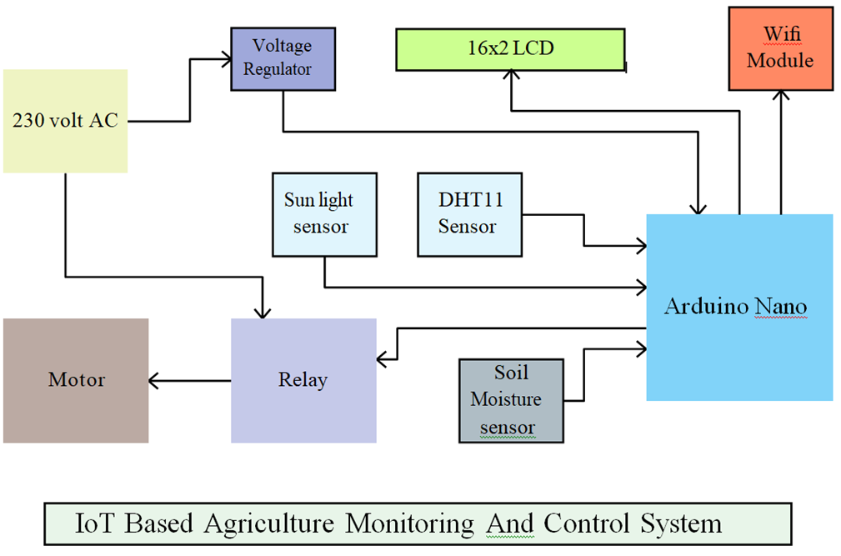

**Figure-3**

Setting up a mechanism to incorporate input from farmers as well as data generated on site. In addition, this loop helps in refining models and making the corresponding recommendations to be precise and appropriate. Setting up a system that constantly monitors the data and informs farmers with alarms or notices about anomalies or critical states in due time. Hence, early warning enables timely response towards avoiding risks and promoting crop safety.

Adapting and refining agricultural methods based on collected data and insights. It entails making strategy changes based on the observed trends that result in increased efficiency and resilience in the long-term.

The project plan gives a structured outline on how to develop an internet of things (IOT) based agricultural monitoring system so that each step is done carefully with regard to implementation in agricultural practices.

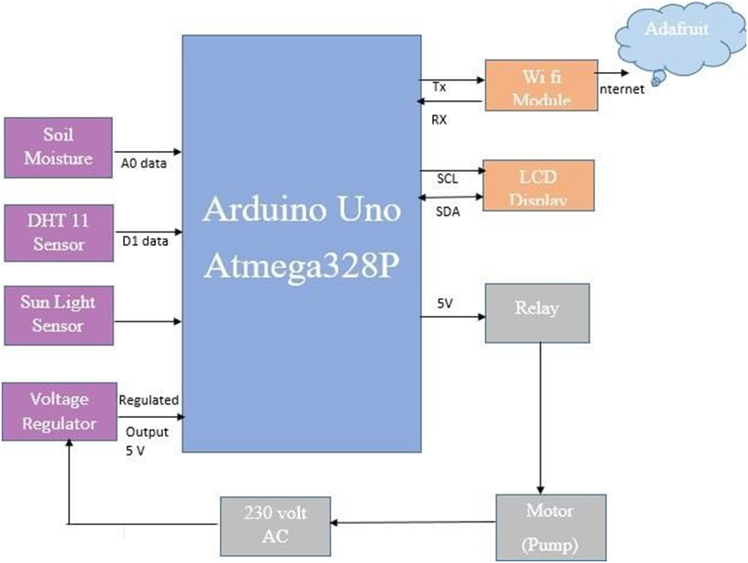

**Figure-4**

An IoT System is composed of three major components; sensors, processors and applications. This implies that the aforementioned model of our project which illustrates the relation between these blocks can be shown in the following diagram. Sensors are connected to Arduino Uno, and the data generated by the sensor is shown on the mobile application developed for the user. The mobile app gives the farmer access to the data from sensors that is continuous, leading to the requirement in a way for farmers to act in compliance with soil needs.

The Arduino system along with the sensors gets energy by means of a small 5 volt regulator.Wi-fi functionally comes from ESP 8266 module. The key component of this assembly is Arduino uno, the central processor which serves as a big brain of the entire assembly.A small photocopier is involved in performing the function of a sensor. Relays in order to actuate a water pump. Moreover, there is an LED connected so that one can check on its performance. A soil moisturesensor is employed to compute the quantity of water present within the soil. LCD is utilized with a view of printing humidity, and moisture readings, a motor status and a light intensity detector. DHT 11 sensor is implemented with a notion of gauging the weather and It supplies water through a process of pumping using an instrument known as a water pump.

**3.3 Data preparation and tools & techniques used**

### 

### Hardware Tools:

##### Arduino Uno:

Arduino Uno is a board that uses an ATmega328 microcontroller (datasheet). It is equipped with 14 digital I/O pins (out of which six are capable of functioning as PWM outputs), 6 analogue inputs, 16 megahertz crystal oscillator, USB port, power plug in, ICSP pin header and a reset option. It includes all requirements for powering the microcontroller; connect it using USB to a PC, an AC-to-DC adapter or power it via a battery source to have it running. Unlike all other previous boards, the Uno does not have an FTDI USB-to-serial driver chip. Unlike the others, however, the Atmega8U2 is configured as a serial-to-USB converter.

**Digital Pins**

Aside from the specific functions described below, digital pins on an Arduino board can be used for general-purpose input and output using the pinMode(), digitalRead(), and digitalWrite() commands. The digitalWrite() function can be used to set the internal pull-up resistor of a pin to either HIGH or LOW when configuring it as an input. The maximum current for each pin is 40 mA.

**Analog Pins**

The analog input pins provide 10 bit analog-to-digital conversion (ADC) using the analogue Read() function in addition to the specialized functions mentioned below. The majority of the analogue inputs, from analogue input 0 as digital pin 14 to analogue input 5 as digital pin 19, can also be utilized as digital pins.The Mini and BT's analogue inputs 6 and 7 are not suitable for use as digital pins.

### Power Pins

The input voltage that the Arduino board receives when it uses an external power source (as opposed to the 5 volts from the USB connection or other regulated power source) is known as VIN (sometimes labelled "9V"). This pin has two possible uses: it can be used to supply voltage or to access it if it comes from the power jack.

### Node MCU:

### It represents an open-source firmware and development kit designed for creating IoT products. This kit involves firmware designed for the ESP8266 WiFiSoC and hardware equipped with an ESP-12 module. The kit features analog (A0) and digital (D0-D8) pins on the board. Furthermore, it supports various serial port communications like SPI, UART, I2C, etc.

### Features:

· The version of the NodeMCU used here is DevKit1.0.

· It can be used on a breadboard easily.

· It is small and lightweight.

The Wi-Fi Module further processes all of the data that the ATmega328 has calculated in order to save it on an IOT (Internet of Things) server or cloud.We are utilizing the well-known IOT platform Ada Fruit to analyze this data on a daily, weekly, and monthly basis.

We use ThinkSpeak, an open-source loud platform programme, in this system. Which utilizes the hypertext transfer protocol (HTTP) to transport data from the local network to the cloud, retrieving and storing it from sensors or other devices connected to systems via the internet? It refreshes all of the data logs obtained from the sensors, location tracking apps, and status applications that are sent to and collected from users. In order to utilize this, the user has set up an account with various

**DHT11Sensor:**

In essence, this sensor is an inexpensive digital temperature and humidity sensor. Despite utilizing an ADC, this sensor provides digital output, allowing it to be connected directly to the microcontroller's data pins. In order to provide temperature and humidity values as serial data, it also has an eight-bit microcontroller. It has four pins: GND, DATA, NC, and VCC.

Temperature is determined using a thermistor, and humidity is determined by measuring the conductivity of a liquid substrate, which changes with humidity exchange. The <DHT.h>library contains a function called read() that is used to obtain readings from the sensor.

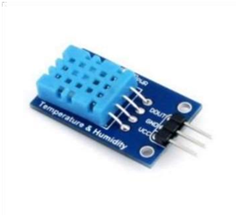

**DHT11 Sensor**

| Parameter | Specifications |
| --- | --- |
| Input/output voltage | 3V / 5V |
| Humidity Range | 20-80 percent |
| Temperature Range | 0-50 deg C |

### Soil Moisture Sensor

Three pins on the moisture sensor are used for ground, voltage input, and analogue input, respectively. Its objective is to evaluate the soil's moisture content as a percentage of volume. The analogue value needs to be mapped within the range of 0-100 because the moisture content is expressed as a percentage. The electrical resistance of the soil is what the sensor is dependent on. Its two probes allow current to pass through the soil, and when the resistance value is measured, the water content level is ascertained. This suggests that as water content increases, electricity conduction rises and resistance decreases. On the other hand, inadequate conduction in dry soil leads to higher resistance.

Performance parameters of Soil Moisture Sensor

| Parameter | Specifications |
| --- | --- |
| Model name | YL-38 |
| Operating Temperature | -40 to +60 deg C |
| Sensing Range | 0-45%volumetric water content of soil |

**Liquid Crystal Display (LCD):**

LCD is used for displaying the voltage, currents and power etc.

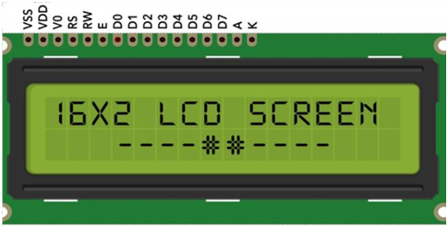**Liquid Crystal Display (LCD)**

**Figure - 4**

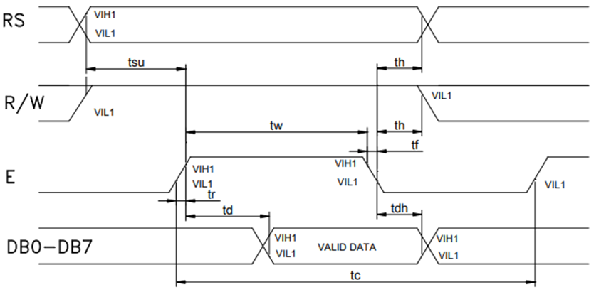

One kind of flat panel display called an LCD (Liquid Crystal Display) operates primarily through the use of liquid crystals. Since LEDs are frequently used in smart phones, televisions, computer monitors, and instrument panels, they have a wide range of applications for both consumers and businesses. LCD stands for liquid crystal display, a type of digital display that changes.A revolutionary era in agriculture has begun with the incorporation of Internet of Things (IoT) technology into crop monitoring systems. This has enabled a paradigm shift away from traditional farming practises and towards data-driven precision agriculture.The agricultural production environment is undergoing a revolution thanks to the convergence of IoT devices, sensors, and advanced analytics, yielding a multitude of outcomes.The optimisation of resource utilisation was one of the biggest effects.

Each autonomous neural network acts as a module and processes distinct inputs to complete a specific component of the job the network is trying to complete.

**Motor**

### This tiny submersible pump, which runs on DC 3-6V, is portable and reasonably priced. able to pump about 120 litres per hour while using a very small amount of current. Keeping the water level up to date is essential because running the motor without any water could lead to overheating and damage to the device's components. This pump has a wide range of uses, such as hydroponic systems and controlled fountain water flow.

### Sun Light Sensor:

A solar cell, also known as a photovoltaic cell, is an electrical device that directly converts small amounts of energy into electricity by means of the PV effect, a physical and chemical phenomenon. It's a device that changes its electrical characteristics—such as resistance, voltage, and current—in response to light. It falls under the category of photoelectric cells. The basic electrical parts of photovoltaic modules are these individual solar cell devices, also known as solar panels. A single-junction silicon solar cell's open-circuit voltage typically falls between 0.5 and 0.6 volts.

Photovoltaic cells are a common term for solar cells, regardless of the type of light source—natural or artificial. They can be used as photodetectors in addition to energy generators.

### 

### Software Tools:

##### Arduino IDE (Integrated Development Environment) :

The main purpose of the Arduino IDE is to write and compile code for the Arduino module. It is an open-source programming tool. The code compilation process is streamlined by this official programming software, making it user-friendly for people of different skill levels. The programme works with all operating systems, including Mac ,Windows. The Arduino Mega, Uno, Leonardo, and other modules are among the many Arduino modules that are available. It has a code editor, text console, message box, and toolbar with buttons for commonly used tasks. C/C++, the primary programming language used in the Arduino Integrated Development Environment, is the software used to create Sketch programmes.Because of their strong functionality, accessibility, and adaptability, Arduino microcontrollers are an essential part of many Internet of things applications for agriculture, and this makes them programming-ready.The primary feature of the Arduino IDE is its user-friendly interface, which makes it easier to programme Arduino-based boards.

This setting offers a user-friendly platform that makes writing and uploading code easier..Additionally, the Arduino IDE can be used with Bluetooth, Wi-Fi, and LoRa, among other communication protocols, which facilitates the connection and data transfer between sensors and the primary parts of a crop monitoring system.This integration transfers sensor data to a central cloud-based platform for additional analysis, interpretation, and visualisation to generate actionable insights.The open-source architecture of the Arduino IDE promotes collaboration and innovation in agricultural technology.This setting enables developers to make changes.Whether you want to use specific sensor data to identify problems or optimize irrigation schedules based on soil moisture levelsDevelopers can use this environment to customize functionality to suit their specific agricultural monitoring needs.Whether you want to optimize irrigation schedules based on soil moisture levels or use specialized sensor data to detect abnormalities in plant health, the Arduino IDE provides the flexibility you need to make such adjustments.and provide resources.

Additionally, the Arduino community supported by the IDE facilitates knowledge sharing and problem solving.Forums, tutorials, and a large user community allow individuals to seek advice, troubleshoot challenges, and explore new possibilities when using Arduino technology for agricultural applications.

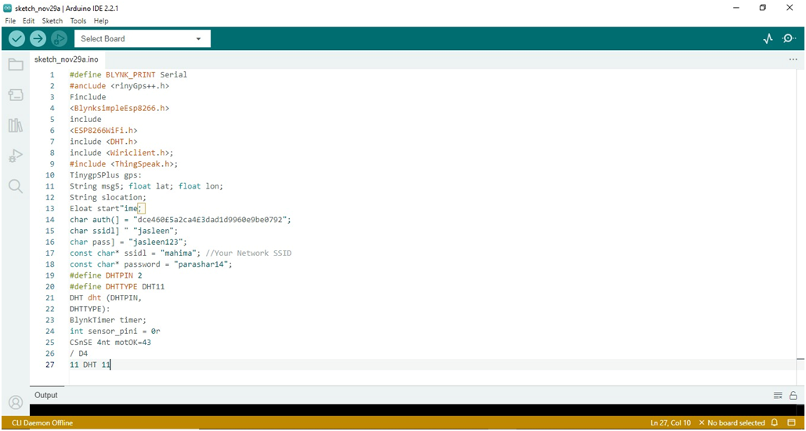Fundamentally, the Arduino IDE serves as the lynchpin for developing, customizing, and deploying IoT-based crop monitoring solutions.Intuitive interfaces, extensive libraries, and compatibility with a variety of sensors and communication protocols enable developers to create sophisticated, customized products that revolutionize agriculture by providing actionable insights to farmers and stakeholders. The Arduino IDE is important for more than just compiling and uploading code.Its role extends to the overall development cycle of plant monitoring systems.During the planning stage, the developer uses her IDE to design sensor integration, communication protocols, and initial coding structures.The simplicity of the IDE allows for rapid prototyping and experimentation.This is important for fine-tuning system functionality before deployment. As developers move into the implementation phase, the Arduino IDE remains an important tool for configuring microcontrollers and sensors.

**Implementation Of Code**

**Thing speak Cloud Server**

The programme is open source. With the help of the services this platform offers, users can view, evaluate, and compile real-time data streaming from cloud servers. It displays real-time visualizations of data uploaded to this cloud server from various devices. On this server, it is capable of running MATLAB code. We are able to process and evaluate statistics as they are received online. It's frequently employed in prototyping.

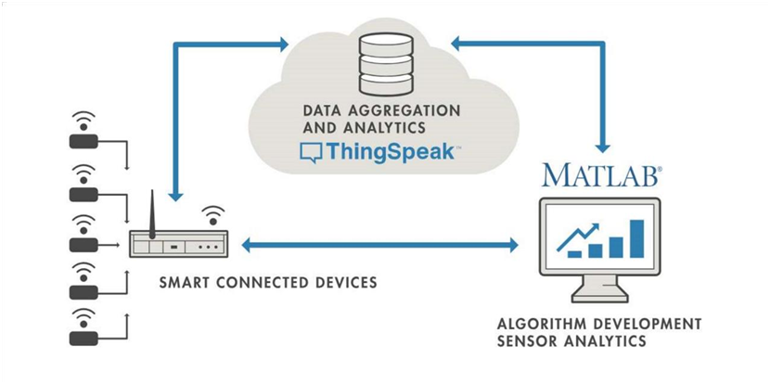Smart devices that reside at the network's edge are located on the left. These gadgets, which gather data, include wearable technology, wireless sensors, heart rate monitors, and more. Real-time analysis of data from various sources is done in a cloud located in the center. The associated algorithm development is shown on the right side.

**Figure - 5**

**Adafruit**:

As a cloud service, Adafruit.io simply means that we manage it for you; you don't have to. It is accessible via the Internet. Although it is primarily intended for data storage and retrieval, it is capable of much more. A crop monitoring system's methodology essentially consists of the methodical gathering, examination, and application of data to provide farmers with timely, accurate, and useful information for effective crop management and decision-making.

1. Adafruit offers a variety of software resources and tools that complement their hardware products, facilitating development and programming for makers, hobbyists, and engineers. Some of the software associated with Adafruit includes:

2. Circuit Python: Adafruit developed Circuit Python, a variant of Python designed for microcontrollers and small embedded systems. It simplifies coding for beginners and allows easy interaction with hardware components..

3. Arduino Libraries: Adafruit provides numerous libraries and example codes for Arduino-compatible boards. These libraries simplify interfacing with various sensors, displays, and components, allowing users to quickly integrate Adafruit hardware into their Arduino projects.

4. Adafruit IO: This is a cloud service provided by Adafruit for Internet of Things (IoT) projects. Adafruit IO enables users to connect their projects to the internet, collect data from sensors, control devices remotely, and visualize data using dashboards.

**3.4 Key challenges**

Developing a crop monitoring system involves overcoming several challenges inherent to the complexities of agriculture, technology integration, and environmental factors. Here are key challenges faced during the development process of such systems

Data Acquisition and Integration: Obtaining accurate and timely data from diverse sources, including satellites, drones, sensors, and weather stations, poses a challenge. Integrating data from multiple platforms and ensuring compatibility between various formats and sensors is crucial but complex. Synchronization and standardization of data for meaningful analysis become critical for effective decision-making.

Assuring data quality and dependability is a significant challenge. Data accuracy may be impacted by variables like environmental factors, signal interference, and sensor calibration. Maintaining data integrity throughout the monitoring process is still difficult, especially in dynamic outdoor environments where weather can change quickly.

Remote Sensing Limitations: Remote sensing technologies, such as satellite imagery and drone data, often face limitations related to resolution, cloud cover, and availability. Obtaining high-resolution imagery consistently and overcoming weather-related obstructions can be challenging, impacting the accuracy of monitoring.

Interpretation and Analysis: Analyzing vast amounts of data collected from different sources requires sophisticated algorithms and computational power. Developing robust algorithms capable of interpreting data accurately, detecting anomalies, and providing actionable insights is a significant challenge. Moreover, translating complex data into understandable and actionable information for farmers adds another layer of complexity.

Integration of IoT and Connectivity: Deploying IoT devices and sensors across vast agricultural landscapes can be challenging due to connectivity issues, especially in remote or rural areas with limited network coverage. Ensuring seamless communication between sensors and the central monitoring system while considering power consumption and signal range is a hurdle.

The performance, monitoring, and maintenance of the plant can be substantially improved by using the Internet of Things Technology to supervise agricultural parameters. Large-scale agriculture is encouraged by the declining cost of renewable energy equipment due to technological advancements. The project's main goal is to remotely monitor and evaluate plant performance through the use of a new, cost-effective IOT-based methodology. Moreover, this project aims to offer data with global utility for advancing agriculture.

• Smart agriculture has the potential to enhance agricultural processes in a more productive, efficient, and sustainable manner.

• Integrating security features is essential for the development of new functionalities.

• Ensuring the protection of sensitive and private data from production through decision-making and storage stages is imperative.

• New security features must prioritize accuracy and reliability.

IoT and technology are used by an agri-tech greenhouse company to deliver services. It uses solar-powered Internet of Things sensors to construct contemporary, reasonably priced greenhouses. With the use of these sensors, the farmer can monitor the condition of the greenhouse and water usage by receiving SMS alerts via an online portal. Information Assortment: Compile up-to-date data on soil health, weather, and crop conditions. - Constant monitoring provides precise information about crop development stages and potential risks. Option Support: - Provide ranchers with substantial experience with precise mediations. - Information-driven decisions for the best water treatment, system, and irritation management.

Stage Improvement: - Foster easy to use interfaces (web or portable applications) for simple information access and perception. - Guarantee similarity with different gadgets and openness from distant areas. Preparing and Training: - Lead instructional courses for ranchers on framework use and translation of information. - Span the mechanical hole to guarantee successful use of the checking framework. Partner Commitment: - Joint effort with ranchers, innovation suppliers, and government organizations for project achievement. - Empower rancher cooperation and criticism for consistent framework improvement.Staged Execution: - Plan an organized rollout thinking about versatility and asset imperatives. - Stages incorporate gadget sending, programming improvement, and rancher preparing. Checking and Assessment: - Persistent observing of framework execution and information precision. - Assess the effect on crop yields, asset proficiency, and monetary advantages. Difficulties and Relief: - Address availability issues in far off regions for consistent information transmission. - Guarantee information safety efforts to shield delicate farming data. - Offer help for ranchers lacking innovative skill. : Compile up-to-date data on soil health, weather, and crop conditions. - Constant monitoring provides precise information about crop development stages and potential risks. Option Support: - Provide ranchers with substantial experience with precise mediations. - Information-driven decisions for the best water treatment, system, and irritation management.

**CHAPTER 04: TESTING**

**4.1 Testing strategy**

Testing a crop monitoring system involves ensuring its reliability, accuracy, functionality, and usability across diverse agricultural scenarios. Here's a strategy outlining the key aspects to consider in testing such a system:

Functional Testing:

Data Collection Validation:Verify that sensors, drones, satellites, and other data collection devices are accurately capturing data. Check for consistency, precision, and alignment with expected values.

Data Integration Testing:Ensure seamless integration and compatibility of data from various sources. Validate the system's ability to aggregate and process data from different formats and sensors.

Performance Testing:

Scalability Testing: Evaluate the system's performance as it scales up to cover larger agricultural areas or increased data volume. Ensure it maintains responsiveness and functionality without degradation. Response Time Testing: Measure the system's response time for data collection, processing, and generating insights. Ensure timely delivery of information for effective decision-making. Load Testing:Simulate heavy loads of data to assess the system's stability and performance under peak usage scenarios.

Data Quality and Accuracy Testing:

Data Accuracy Validation: Cross-check collected data with ground truth measurements established standards to validate accuracy. Address any discrepancies found.

Reliability Testing: Assess the system's reliability by monitoring data collection during adverse conditions such as weather fluctuations or signal interference.

Usability and User Interface Testing:

User Experience Testing: Evaluate the user interface and overall user experience. Ensure the system provides actionable insights in a user-friendly manner.

Accessibility Testing:Verify that the system and its interfaces are accessible across various devices and platforms commonly used by farmers.

Security and Privacy Testing:

Data Security Testing: Conduct security audits to identify vulnerabilities in data transmission, storage, and access. Implement robust encryption and authentication measures to protect sensitive agricultural data.

Privacy Compliance Testing: Ensure compliance with privacy regulations.

Field Testing and Validation

On-field Validation: Test the system's performance in real agricultural environments across different crops, terrains, and weather conditions.

Feedback and Iteration: Gather feedback from farmers and end-users during field trials. Use their input to improve system functionality and usability.

End-to-End Testing: scenario-Based Testing: Simulate real-world scenarios to test the entire system's end-to-end functionality. Evaluate how the system responds to specific conditions and events.

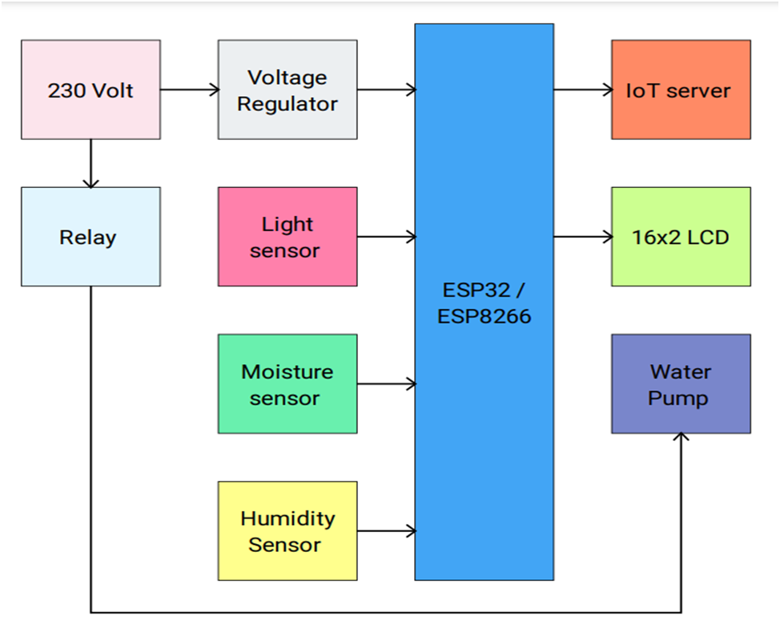

**Figure - 6**

**Arduino IDE:**

It includes a text editor for writing code, a message board, a text console, and a toolbar with buttons for commonly used tasks. The programmes made with this software are called sketch programmes. The primary programming language used in this software is C/C++ functions. Code for Arduino modules is written and assembled using an open-source programming tool called the Arduino IDE. With an easy-to-use interface, it streamlines code compilation and is suitable for users of different skill levels. It provides a flexible platform for programming microcontrollers and is compatible with a variety of operating systems and Arduino modules.



**Sketch Area of Arduino**

**Arduino sketch**

An example of an Arduino sketch with a variety of toolbar icons can be seen in the above figure. You can save a project, open previously saved or created projects, upload, and check using the icons on the left. The first icon on the left denotes verification. To access the serial monitor, click the symbol located on the far right.

The white section in the middle is the coding area. Writing and compiling code for the Arduino module is the main use of the open-source Arduino IDE programming tool. Even for the typical user, code compilation is made simpler and easier to understand with the aid of this official programming software. With versions available for Windows, Linux, and Mac, anyone can easily access the programme. Many Arduino modules, including the Mega and Uno variants, Testing for Scalability: Analyse the system's performance as it expands to handle more data or bigger agricultural areas. Make sure its functionality and responsiveness don't deteriorate. Testing Response Time: Determine how quickly the system gathers, processes, and interprets data. Make sure information is delivered on time so decisions can be made wisely.

**Techniques used**

IoT-based crop monitoring systems use a wide range of methods and tools to effectively collect, handle, and use agricultural data in contemporary agricultural environments. A plethora of sensor technologies positioned strategically across fields form the foundation of these systems. These sensors have a wide range of uses, including weather stations, humidity gauges, and sensors for temperature and soil moisture. Their combined job is to continuously collect real-time data on critical agricultural parameters so that environmental factors, crop health indicators, and soil conditions can all be fully understood. These sensors connect to microcontrollers such as Arduino, Raspberry Pi, and other Internet of Things devices to form a network of data collection points. The transfer of this data to cloud-based platforms is made easier by communication protocols like Bluetooth, Wi-Fi, Zigbee, and LoRaWAN.

The collected data is subjected to complex processing and analysis in the cloud, which is an essential step in producing insights that can be put to use. Large volumes of data are handled effectively by cloud-based data storage systems, and significant patterns, trends, and anomalies are extracted by data processing algorithms. Predictive modelling, which provides forecasts on weather patterns, pest infestations, or crop yields based on historical and real-time data, is made possible by advanced analytics, including machine learning algorithms. By enabling local data analysis and quick sensor-level responses, edge computing enhances this process even more by lowering latency and dependence on centralised cloud processing.

User interfaces and visualisation tools are essential for making this data understandable and useful. Farmers can easily access interpreted data through dashboard interfaces and mobile applications, which present historical trends and real-time metrics in an easy-to-use format. Farmers receive timely alerts and notifications based on data analysis that offer insights into critical conditions, possible risks, or suggested agricultural interventions.Security protocols are still of utmost importance in these systems. Sensitive agricultural data is kept confidential and intact throughout transmission and storage thanks to encryption protocols. User permissions are governed by access controls, protecting data privacy and adhering to industry standards.

**Chapter 5: RESULTS**

**5.1 Results**

The outputs of a crop monitoring system are diverse and important in managing farms effectively. Such results emanate from data collected, analyzed and processed by the system. Here are key results generated by a crop monitoring system:

Crop Health Assessment: This system gives information on the crop condition. This determines the changes in vegetation indices, leaf coloration and growth patterns which could point out any stress factor, disease or an attacking pest. Environmental Conditions: The environmental parameters such as soil moisture, temperature, humidity, and weather forecast help a person understand the conditions that affect plant growth. This system provides up-to-date information about these measures that guide farmers into proper crop management.

Predictive Analysis: The system utilizes data from previous years and at present to make forecasts concerning crop yields, infestation by pests, and optimum period of harvesting. These predictions assist in planning and decision-making for improved productivity.Irrigation Optimization: Using the soil moisture and weather forecast data, the system provides precise irrigation schedules for optimal utilization of water without undershoots or overshot.

Nutrient Management: The system provides information about optimizing fertilization strategies based on insights obtained. By analyzing soil nutrient levels and crop requirements, the system recommends appropriate fertilization schedules and application rates.Pest and Disease Management: Pests, diseases, and abnormalities can be detected early to allow fast action. The system warns farmers of possible dangers and lets them take preventive measures to limit the level of destruction.

Decision Support System: This makes it possible to offer detailed actionable insights and recommendations through very intuitive interfaces. Farmers receive alerts, reports, and visual representations of data, aiding in informed decision-making.Yield Estimation: The system utilizes historical as well as current data for calculating anticipated crop yields. Such data assists the farmer in formulating logistical planning and forecasting market supply as well as 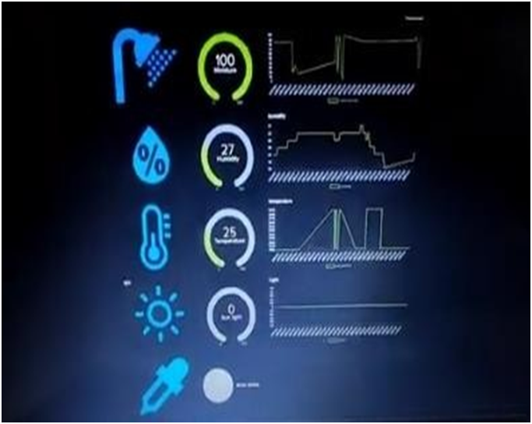other key issues for purposes of better decision making in the business.

**Adafruit**

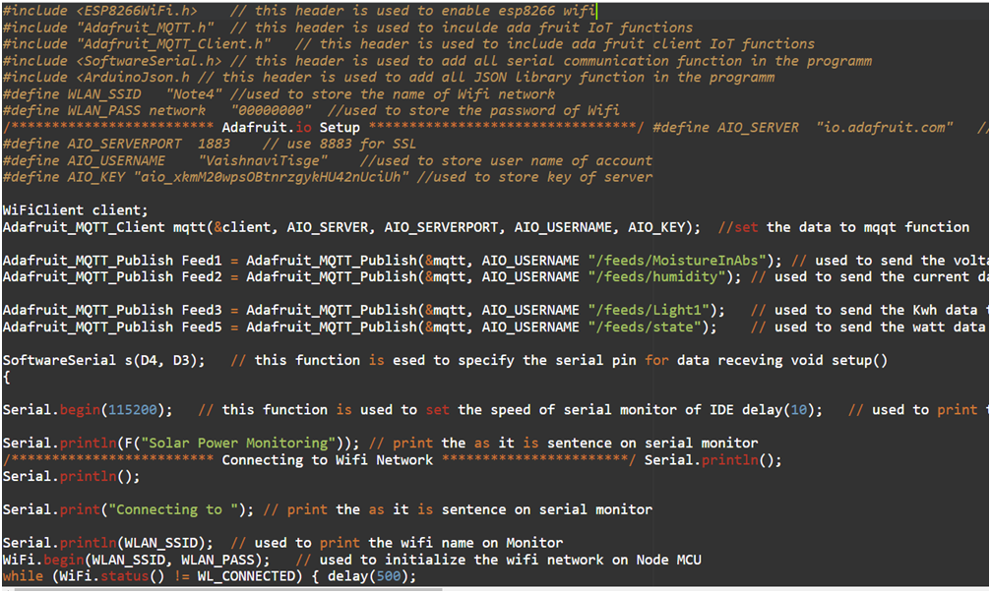

**ARDUINO IDE**

The incorporation of internet of things (IoT) technology into crop monitoring system has brought into a new age in Agriculture towards precision agriculture based on data rather than traditional approach. One of the key impacts was optimized resource utilization. For example, sensors that are equipped with IoT technology and positioned directly in the field supply continuous information regarding such parameters as moisture, temperature, and humidity, etc. Information is updated immediately and the farmer gets timely information about the status of his crops. Farmers may utilize such information for proper optimization of irrigation schedules that enhance moisture retention in soils while conserving limited water resources. The same goes for targeted fertilization and pest control, which uses sensors to monitor usage, thereby preventing overuse, wastage, and enhanced Farmers get alert warnings about abnormalities detected at an early stage through pests, bad weather and etc. It involves quick response that helps reduce risk and crop losses. The crop yield is enhanced as well as ensures healthy, strong crops with real-time data. The other milestone achieved was in giving power to farmers via remote support and data informed decisions.

Farmers are increasingly able to monitor fields and analyse trends through access to vital data available from anywhere. Moreover, with remote monitoring capabilities, farmers can quickly deal with problems without going to the fields, which in turn increases operational agility and responsiveness. Farmers who utilize a sustainable form of farming minimize inputs such as water, fertilizers as well as pesticides. Through this, they are able to save on resources without affecting the level of crop output. In turn, they increase their profits so that they can be able to operate sustainably

Also, these strategies help to nurture durable farming techniques. Instead of relying on guesswork, they switched to precision farming, which is based upon the insight from available data. The emphasis on sustainability, which entails reduced chemical usage, ensuring healthy soils, as well as protecting water resources, falls in line with environmental obligations across the globe and is

The essence is that incorporating IoT in crop monitoring systems gives rise to resource optimization, enhanced yields, preventive risk management, better choices, lower expenses, and environment-friendly farming approaches.

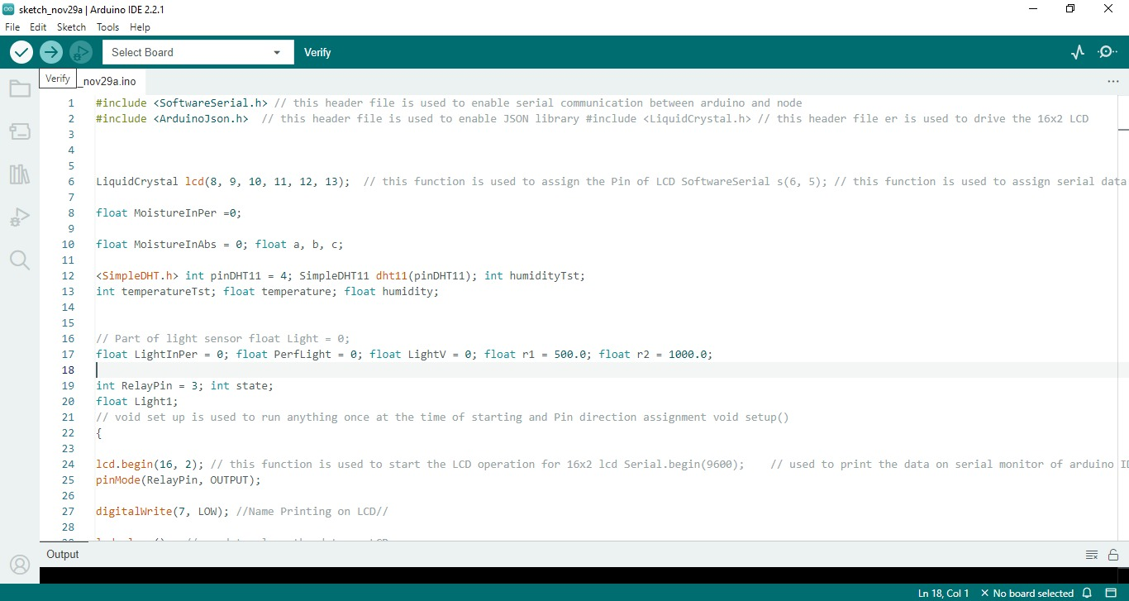

Code wrote in the software

**CHAPTER 06: Conclusion**

**6.1 Conclusion**

The invention of an IoT crop monitoring system is a revolutionary deposit in the domain of agriculture, bringing immediate awareness of conditions and accurate info for better crop management. This system integrates detectors, data collection, and analysis in order to provide practical information that is timely and helpful to a grower for making an informed decision on timber use.

The innovative output contributes to colorful agrarian problems solutions thanks to continuous evaluation of moisture, temperature, moisture content and the presence of insects. This enables growers to react and direct resources accordingly in response to unstable conditions; therefore enhancing yielding.

Just like this, the perpetuation of prophetic models and analytical methods based on accumulated data supports visionary actions such as water efficient scheduling, targeted pest management and resources utilization. It is also user friendly as it has some stone friendly interface and warnings that can be adjusted which enables growers to easily understand the data. Finally, this IoT driven crop monitoring system forms an important aspect of perfect agricultural practice, promoting maximum yield, minimal resource waste and sustainable agriculture.

This model is based on IoT (Internet of effects) which has application in the husbandry sphere. This is a hybrid cropping system that aims at adding the crop yield through forecasting suitable sequences of crops for specific soils. Therefore, thingspeak enables a slice of the soil in real-time, making this data available for analyzing the crops. In addition we have also had several readings of the soil humidity, temperature and moisture level for colorful days during several times of the day. The agronomists also use the data of the pall to improve cropping, evaluate the coprolites as well as illnesses occurring in the fields. This is a cheap, realistic system.

The latter strategy encompasses enhancing utilization of water coffers including addressing problems such as water failure with a view towards fostering sustainability. The outcome of this study is geared towards enhancing farming methods in order to improve efficiency of lowly resources available.

#### 6.2 Future Scope

IoT promises a lot for the compass of crop monitoring systems of unborn. It willrevamp the husbandry by adopting the slice- edge technologies in order to face the emerging challenges and improve efficiency as follows.

Advanced Sensor Technology

· Improved multispectral imaging through integrating the latest sensors (multispectral cameras) into crop assessment systems capable of identifying conditions in the earliest stages or under-nourishment.

(f) Drones technology – Application of drones provided with sensors capable of carrying out fast and complete data gathering on a larger scale. AI and Machine Learning Integration

· AI-based enhanced prophetic analytics algorithms (prophetic analytics). Including vaccination forecast to crop development, complaint outbreak prediction as well as yields estimation. AI- assisted precision recommendation systems providing specific intervention tips like accurate irrigation and effective pest management techniques.

Connectivity and Edge Computing

Fifth Generation Integration – 5G enables smooth data flow as it has quick response times and real time monitoring.

Edge Computing – perpetuating a ‘bias towards data processing at the periphery’, expediting quietude and making decision timbre.

Sustainability and Environmental Impact

Precision resource management – deeper analysis of real-time data about water operations in order to optimize the process itself. Climate resilience integration of climate modeling and data to aid farmers to adapt to changing climatic situations and survive against environmental threats.

The combination of Blockchain and IoT ecosystems.

· Force chain translucency – Block chain technology as an improved traceability and transparency within the agrarian force chains, icing quality control and reduction of food wastage.

Integration of a larger IoT ecosystem that integrates diverse farming applications for smooth farm management.

However, in the yet to be born future iterations of the crop monitoring systems based on IOT, advanced methods should be put forward, making these models more suitable for contemporary agriculture.

**APPLICATIONS**

The crop monitoring systems are employed in several stages that entail information, assists, and guidance to farmers and interested parties. Here are key applications of crop monitoring systems:

· Yield Prediction and Forecasting: Crop monitoring systems that analyze historical and real-time data can help predict yields of specific crops. The projections help with crop preparation, market estimations, as well as more suitable distribution of resources for enhanced economic gains.

**REFERENCES**

1.Rajalakshmi.P, Mrs.S.DeviMahalakshmi“IOT@ Based Crop-Field Monitoring And

Irrigation Automation” 10th International@conference on Intelligent systems and control

(ISCO), 7-8 Jan 2016 published@in IEEE Xplore Nov 2016.

2. S.Sivachandran, K.Balakrishnan, K.Navin, “Real@Time Embedded Based Soil Analyser”,

International Research@ Journal of Engineering and@Technology (IRJET). Volume: 3 Issue 3 |

March 2014

3. Anand@Nayyar, Er. Vikram Puri, “IoT Based@Smart Sensors Agriculture Stick for Live

Temperature and@Moisture Monitoring using Arduino, Cloud@Computing &amp; Solar Technology”

May 2015.

4. Chandan Kumar@Sahu, Pramitee Behera, “A Low@Cost Smart Irrigation@Control System”,

IEEE sponsored 2nd International Conference on Electronics and Communication@System

(ICECS2015)

5. Laxmi C. Gavade, A.D Bhoi , “N, P, K Detection and Control@for Agriculture Applications

using PIC Controller”, International@Research Journal of Engineering@and Technology (IRJET).

Volume: 6 Issue: 4 | April 2017@

6. Lu, D., & Weng, Q. (2006). "Spectral mixture analysis of the urban landscape in Indianapolisbbwith Landsat ETM+ imagery." Photogrammetric Engineering & Remote Sensing, 72(12), 1397-1406.

7. Lobell, D. B., et al. (2009). "Satellite detection of earlier wheat sowing in India and implications for yieldbbtrends." ClimatebbResearch, 39(3), 165-171.

8. Chen, D., Huang, J., Jackson, T. J., & Veroustraetebb, F. (2005). "Agriculturalbbvegetation modeling and monitoring using satellitebbdata: A review." PhotogrammetricbbEngineering & Remote Sensing, 71(12), 1381-1399.

9. Colomina, I., & Molina, P. (2014). "Unmanned aerial systems forbbphotogrammetry and remote sensing: A review." ISPRS Journal of Photogrammetry and RemotebbSensing,92, 79-97.

10. White, J. W., Hoogenboom, G., & Stackhouse Jr, P. W. (2008). "Evaluationbbof NASA satellite-and assimilation model-derived long-term daily temperaturebbdata over the continental US." Agricultural and ForestbbMeteorology, 148(9), 1574-1584.

11. Gao, B. C., et al. (2009). "MODIS BRDF/Albedo product: Algorithmbbtheoretical basis document version 5.0." MODISbbLandbbAlgorithm. DOI: 10.5067/MODIS/MCD43B1.005.

12. Olofsson, P., Foody, G. M., Herold, M., Stehman, S. V., Woodcock, C. E., & Wulder, M. A. (2014). "Good practices for estimatingbbarea and assessing accuracybbof land change." RemotebbSensing ofbbEnvironment, 148, 42-57.

13. Wardlow, B. D., Anderson, M. C., & Egbert, S. L. (2011). "Abbcomparison of MODIS 250-m EVI and NDVI data forbbcrop mapping: a case study for southwest Kansas." International Journal of RemotebbSensing, 32(2), 661-697.

14. Justice, C., Townshend, J., Vermotebb, E., Vermote, E., & Defries, R. (1998). "The Moderate Resolution Imaging Spectroradiometerbb (MODIS): Land remote sensing for global change research." IEEE Transactions onbbGeoscience and Remote Sensing, 36(4), 1228-1249.

15. Wulder, M. A., White, J. C., Lovelandbb, T. R., Woodcock, C. E., Belward, A. S., Cohen, W. B., ... & Zhu, Z. (2016). "The global Landsatbbarchive: Status, consolidation, and direction." Remote Sensingbbof Environment, 185, 271-283.

16. Tucker, C. J. (1979). "Redbb andbbphotographic infrared linear combinations for monitoring vegetation." Remote Sensing of bbEnvironment, 8(2), 127-150.

17. Huete, A. R. (1988). "A soil-adjustedbbvegetation index (SAVI)." Remote Sensing of Environment, 25(3), 295-309.

18. DeFries, R. S., & Chan, J. C. (2000). "LAICP97 landbbcover classification." Boston University, Bostonbb, MA, USA.

19. Friedl, M. A., bbMcIver, D. K., Hodges, J. C., Zhang, X. Y., Muchoney, D., Strahler, A. H., . &Woodcock, C. E. (2002). "Globalbbland cover mapping from MODIS: algorithms and earlybbresults."

20. Hansen, M. C., DeFries, R. S., bbTownshend, J. R., & Sohlberg, R. (2000). "Global land cover classification at 1 km spatialbbresolution using a classification tree approach." International Journal of RemotebbSensing, 21(6-7), 1331-1364.

21. Friedl, M. A., Sulla-Menashe, D., bbTan, B., Schneider, A., Ramankutty, N., Sibley, A., & Huang, X. (2010). "MODIS Collectionbb5 global land cover: Algorithm refinements and characterization ofbbnew datasets." Remote Sensing of Environment, 114(1), 168-182.

22. Di Gregorio, A., & Jansen, L. J. (2000). "Land coverbbclassification system (LCCS): Classification concepts and user manual." Environment andbbNatural Resources Service, Sustainable Development Department, Food and AgriculturebbOrganization of the United Nations.

23. Justice, C. O., Vermote, E., Townshendbb, J. R., Defries, R., Roy, D. P., Hall, D. K., ... & Salomonson, V. V. (1998). "The moderatebbresolution imaging spectroradiometer (MODIS): Land remote sensing for global changebbresearch." IEEE Transactions on Geoscience and Remote Sensing, 36(4), 1228-1249.

24. Woodcock, C. E., Strahler, A. H., & bbJupp, D. L. (1988). "The use of variograms in remote sensing: II. Real data." RemotebbSensing of Environment, 25(3), 349-361.

25. Jupp, D. L. B., Strahler, A. H., & Woodcock, C. E. (1989). "A global comparison of alternative algorithms for estimatingbbfractional vegetation cover from NDVI." International Journal of RemotebbSensing, 10(12), 1699-1737.